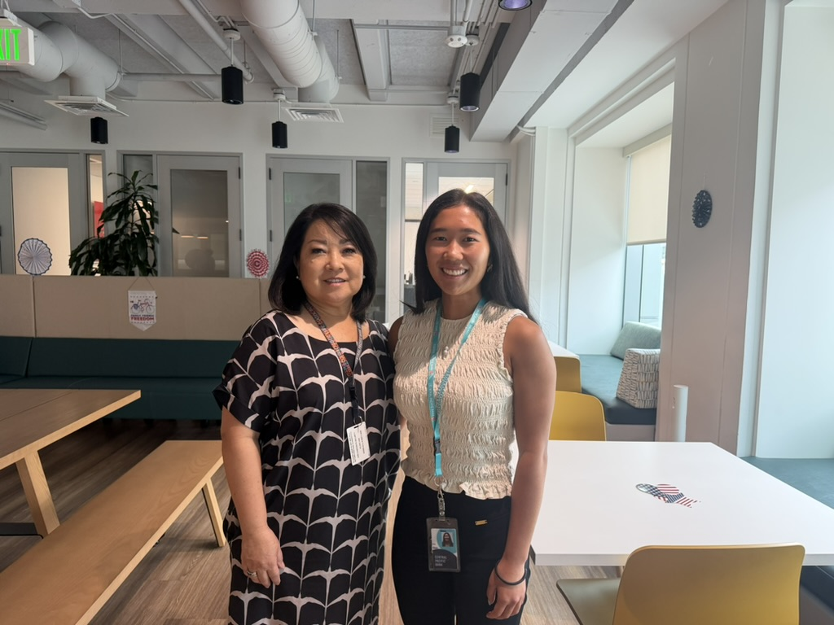

Helping More Than Small Businesses: Susan Utsugi’s Impact Through Relationship Banking
From early values in community service to guiding small businesses reflects her incentives to go beyond banking

Susan Utsugi grew up understanding the importance of community service, a value her father instilled as she watched him consistently volunteer. The early values for giving back to the community contributed to the reason why Susan decided to go into business banking - to help others. To Susan, business banking is more than transactions – it’s a people business. There is a good balance between the analytical side and the ability to help people grow their small businesses.

Susan began her career at another local bank through a Management Trainee Program, where she built a strong foundation in financial literacy and analytical thinking with financial statements, which are key assets. Later, she was encouraged by a former mentor to switch to Central Pacific Bank – a pivotal shift in her career. There, she found a voice and flexibility with the opportunities to expand her impact through collaboration. As she continued to demonstrate her capabilities, new opportunities arose and eventually led her to the executive level.

COVID-19 was a defining moment in Susan’s career – the moment where she knew she was in the right industry and alongside the right people. During the pandemic, small businesses struggled to sustain their livelihoods. As a result, Susan and the CPB team ensured that small businesses received Paycheck Protection Program (PPP) funding to continue operating and retain employees. The CPB team worked long hours and proved their dedication to helping small businesses by working late nights and nearly 7 days a week, processing applications in the PPP loan portal. Being part of a company culture committed to helping others was very encouraging, and Susan says that the “Team effort was very gratifying to see how everyone stepped up for our state.” To this day, she still runs into small business owners CPB helped with PPP loans, and they are full of gratitude and so appreciative of the work we put in. Simply put, we went beyond banking to make a positive difference, which reflects the core values – Voyaging Spirit and Positively Ohana.

With years of experience, Susan has come to view her role from a broader perspective, which is to help bankers succeed and drive small business initiatives so that CPB is the best bank for small business. She describes a banker as “the quarterback to the relationship” – someone who understands the client’s business, anticipating their needs, and brings in the expertise to support them. From helping entrepreneurs launch their businesses, build success, and strategically exit, Susan’s work is deeply rooted in long-term relationships. Through this personal connection and deep analytical insight, her role is effective and rewarding.

