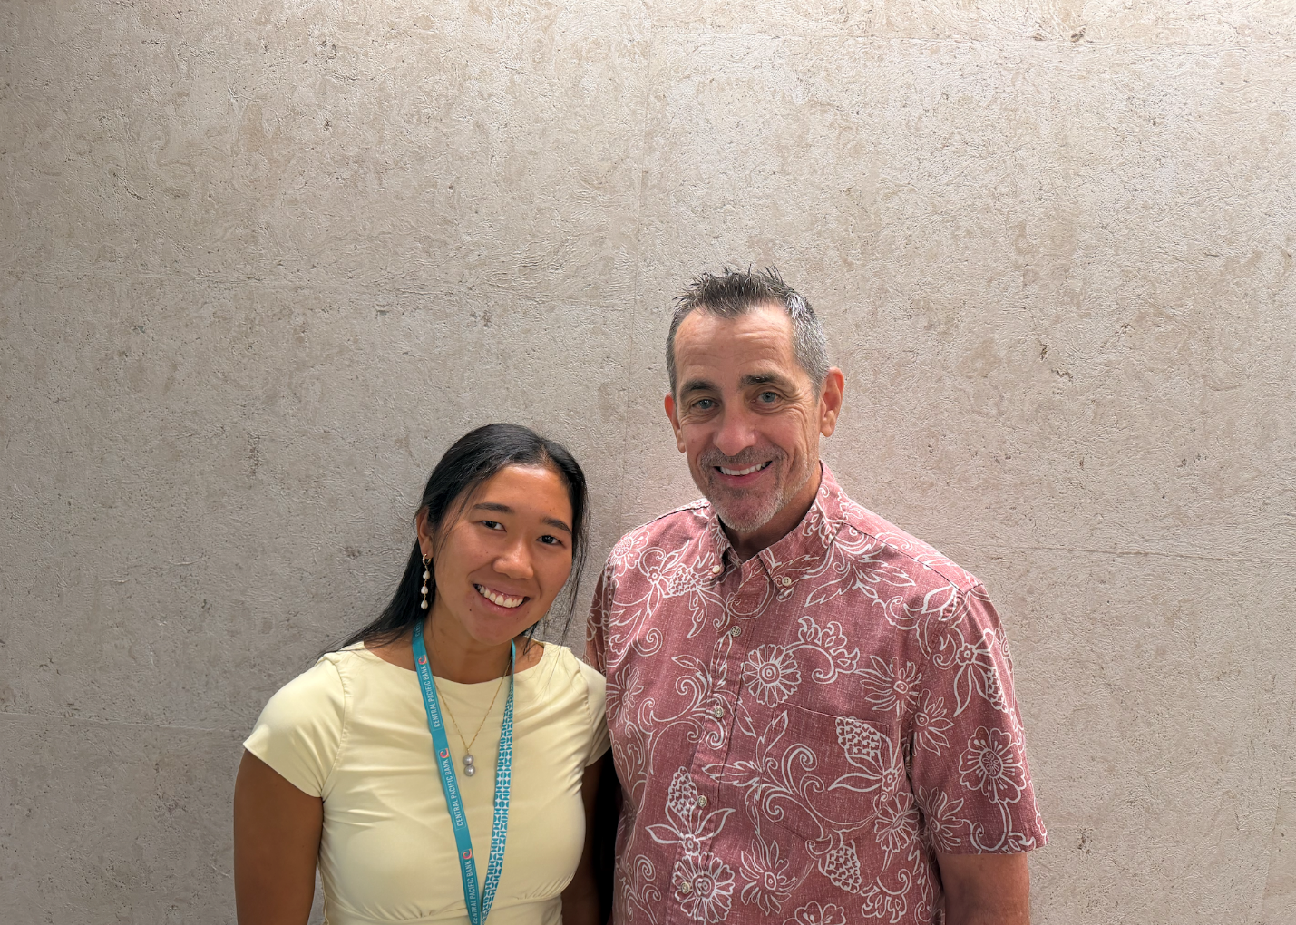

From Serving the City to Pursuing a Passion
Ralph Mesick’s career reflects values derived from his upbringing, shaping his net contribution.

Ralph Mesick describes himself as a shy person who struggles with focus and attention, but after interviewing him, a different picture emerges. I see someone who is humble, intelligent, and pensive. His career journey tells a story of someone who persistently made the most of his assets and thrives in what he loves most.

Ralph began his professional path at the Honolulu Police Department, where he attended a luncheon for the 200 Club, an organization composed of 200 business leaders that awards exceptional first responders. He met successful businessmen who advised him to study finance, which led him to college to earn a degree, and he later landed his first banking job at another local bank. He was able to gain a foundational skillset -learning how a company generates money, understanding the industry, and evaluating management, which led to future leadership opportunities. After serving as an Executive Vice President, Ralph moved to another local bank, where he retired. However, within a year of his retirement, he decided to return to the banking industry and join Central Pacific Bank.

Ralph came out of retirement because he missed banking. To him, banking is more than just numbers. It’s about how rewarding it is to support people through financial expertise and guidance to help people solve these problems of pension obligations or funding retirement, and in the process, to see how far they have come along the way.

Ralph has a very analytical and financial-oriented way of thinking by seeing life through a risk management perspective, whereas your everyday life involves risk - crossing the street is a risk. By taking risks, rising to challenges, and being inquisitive, he has achieved many proud accomplishments. Ralph has made deals that have enabled him to finance several buildings across Honolulu.

At the core of his journey are values that are instilled early in life. As a proud Catholic, he credits the lessons his parents and teachers taught him at a young age. In 2nd grade, he was taught the concept of stewardship by living life to the fullest, creating meaningful values that help you make the right decisions, and ultimately becoming an incentive to succeed. Also, he lives by the Golden Rule - by treating others the way that you want to be treated through the concept that life is asymmetric. “Stress the value of stewardship to someone who aspires to do much in life. I think if you do much with what you are given and take care of things that people trust you with, you will be asked to do more and have the opportunity to be engaged in a lot of meaningful things.”

